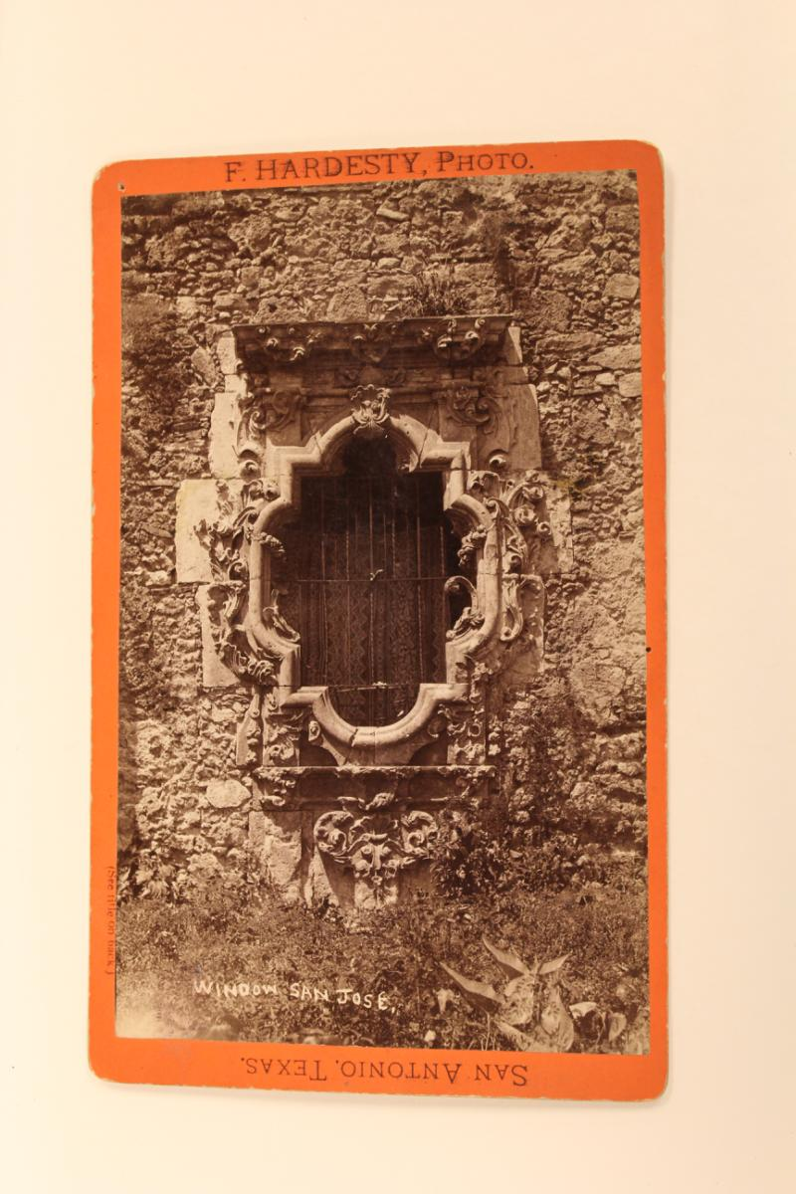**Draw a Rose Window**

Have you ever noticed the beautiful windows on old buildings, especially churches and cathedrals? You may see windows that resemble a flower – these are rose windows. One beautiful example of a rose window is found at Mission San Jose. The four “petal” shapes that make up the outer part of this window are the reason it is also a **quatrefoil**.

**Materials Needed:**

Pencil

Eraser

Frank Hardesty, “Window, San Jose.” Silver gelatin process, Briscoe Western Art Museum permanent collection.

Markers, Crayons, or Colored Pencils

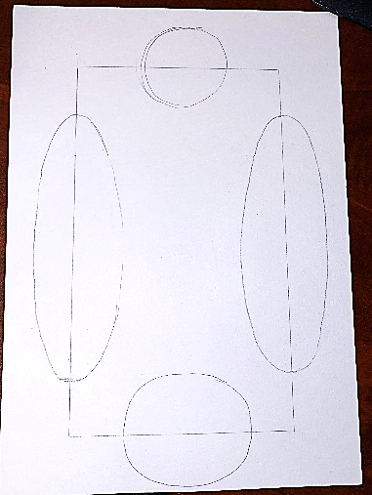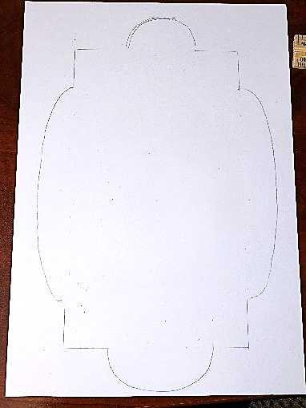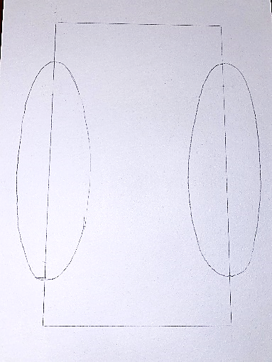

**Step 1:** With your pencil, draw a tall rectangle.

**Step 2:** Draw a large oval on each long side of the rectangle.

**Step 3:** Draw a circle on the top and bottom edges of the rectangle.

**Step 4:** Erase the lines inside the original rectangle shape. Then erase all the lines that go through the circles. You will be left with an outline.

**Step 5:** Trace the outline of your rose window and then decorate it. Add details like the window panes and frames, or even a spider web hanging in the corner.

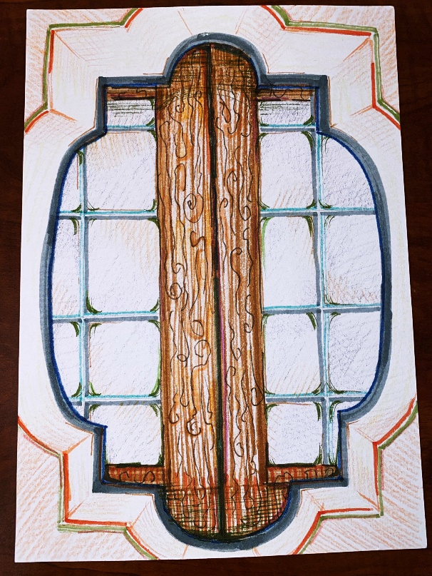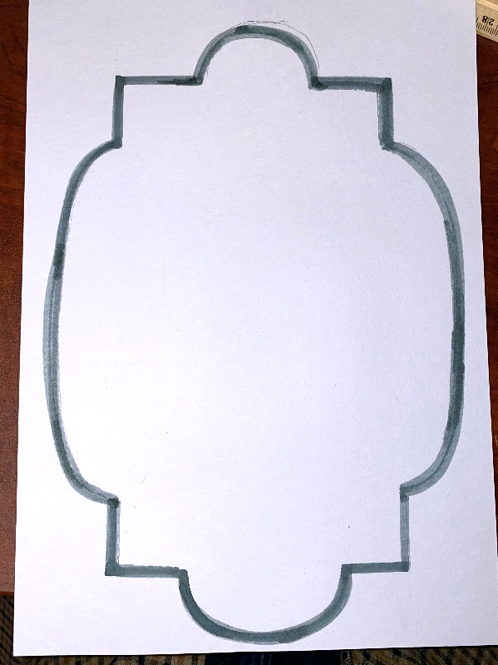

Take a photo of your rose window and share it with us online. Be sure to tag **@BriscoeMuseum** and use the hashtags **#BeyondTheBriscoe** and **#TheWestStartsHere** so we can find your work of art.