Bison
The American bison was named the national mammal of the United States in 2016. It’s one of our greatest conservation success stories of all time.

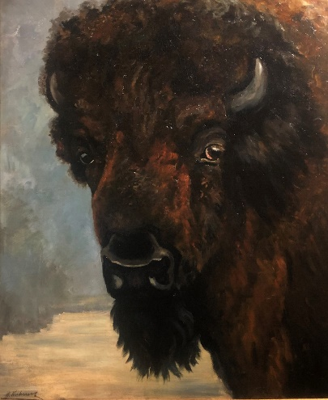
Bison, Wilhelm Kuhnert (1865-1926)
Bison are the largest mammal in North America. Male bison (called bulls) weigh up to 2,000 pounds and stand 6 feet tall, while females (called cows) weigh up to 1,000 pounds and reach a height of 4-5 feet. Bison calves weigh 30-70 pounds at birth. Bison may be big, but they’re also fast. They can run up to 35 miles per hour. Plus, they’re extremely agile. Bison can spin around quickly, jump high fences and are strong swimmers.

Ask Yourself:
Why are bison so important to the history of America and the West?

What do you think was the Native Americans used bison for in their daily lives?

BISON ART
Think about what you learned about bison.
Apply this knowledge as you create your own bison.
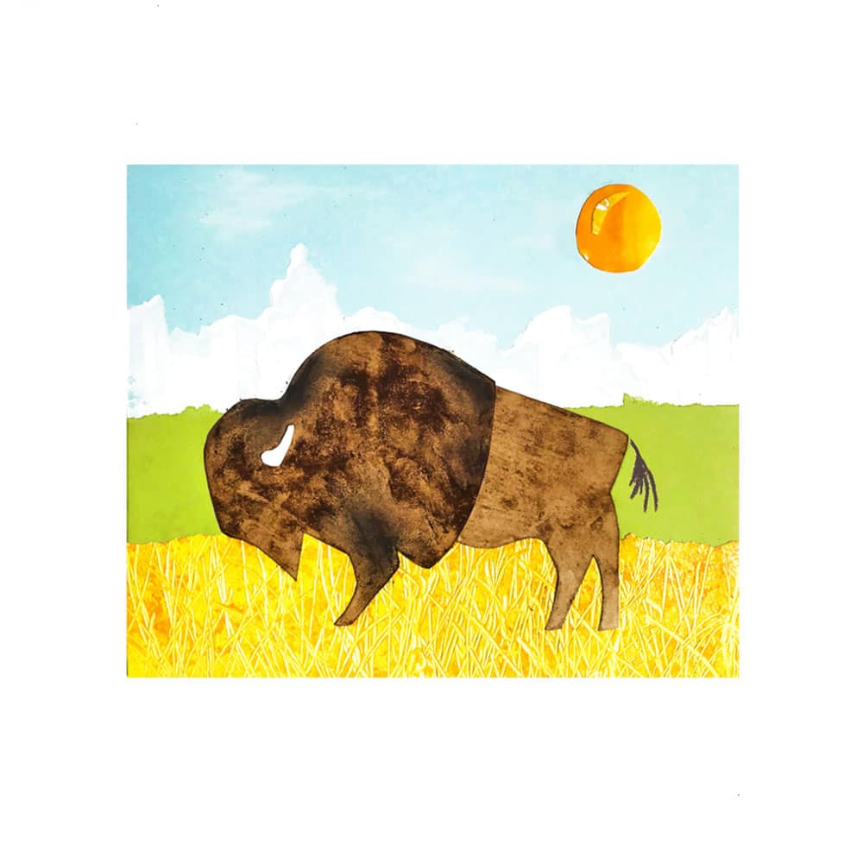

Materials:
Cardstock, watercolor, or other heavy paper
Acrylic or tempura paint and a paintbrush
Construction paper in different colors
Dried coffee grounds
Scissors
Glue stick

Directions:

Step 1: Cut out Bison.

Step 2: Add a little water to your coffee grounds to make them wet so they will brush on.

Step 3: Pint the front and back of your bison with the coffee grounds until it is completely covered.

Step 4: Set the back half aside. Continue adding coffee grounds to the front part to make it darker and more textured.

Step 5: Set aside your bison to dry.

Step 6: Glue 2 pieces of torn scraps of paper onto the cardstock. (Overlap the torn paper to create your landscape.)

Step 7: Tap or brush extra coffee grounds off of your bison and then glue him to the background.

Step 8: Paint a mountain range, clouds, sun or other objects onto background. Add details to your bison.

